Chapter 13, Problem 84.

Determine I₁, I₂, and I₃ in the ideal transformer circuit of Fig. 13.143 using PSpice.

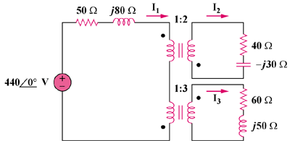

Figure 13.143
For Prob. 13.84.

